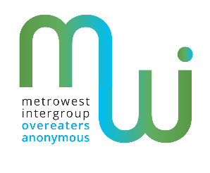 Metrowest Intergroup Presents
CARRY the MESSAGE
OA step 12
Having had a spiritual awakening as the result of these steps, we tried to
carry this message to compulsive overeaters and to practice these principles in all our affairs.

OA Tradition 5
Each group has but one primary purpose — to carry its message to the compulsive overeater who still suffers.

This Outreach Campaign Workshop will focus on how you can be of service. We will read and share about speaking to Newcomers, Sponsorship and Public Outreach. We will discuss and demonstrate speaking to your Clergy, Medical and Psychological Professionals about OA.

We want to know your ideas on carrying the message!

Date: Sunday, October 27th, 2019
Time: 1:30-4 PM
Location: Metrowest Medical Center
115 Lincoln Street
Perini Auditorium
Framingham, MA 01702

Contact Information: Metrowest Intergroup of Overeaters Anonymous: 508-875-0001
Please bring your OA 12 Steps & 12 Traditions and Big Book

